EXPERIMENT – 5
FEATURE SCALING IN GIVEN DATASET
Aim:
To provide feature scaling for a given dataset

Procedure:
1.Upload the given csv file
2. Import the necessities like numpy and Pandas
3. Use pandas to read_csv and make it as an data frame
4.Now use SimpleImputer to fill missing values

Program:
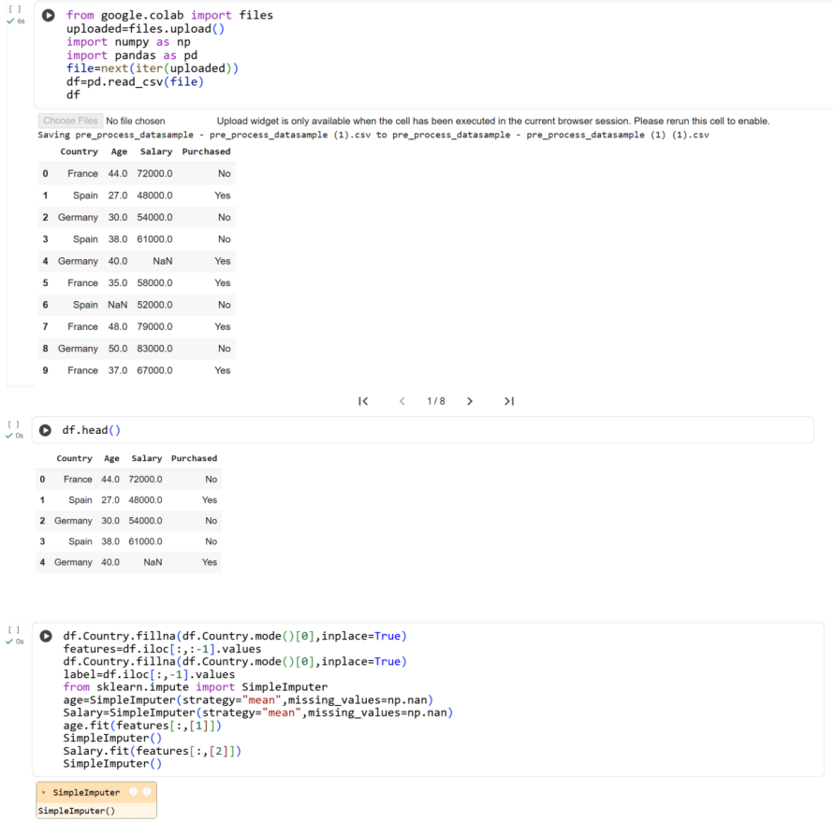
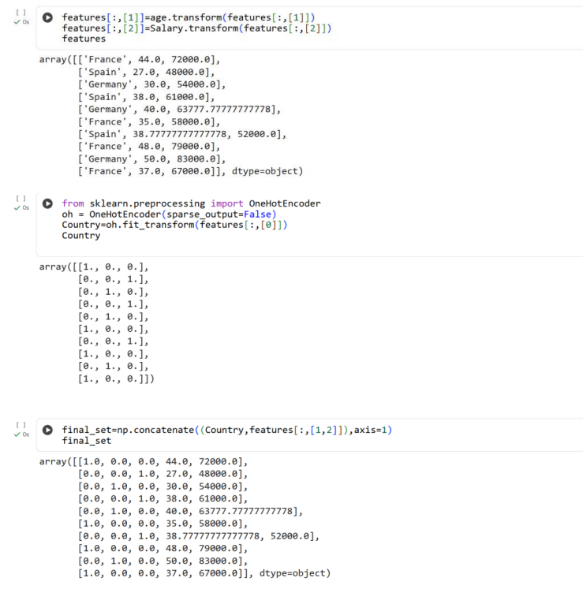
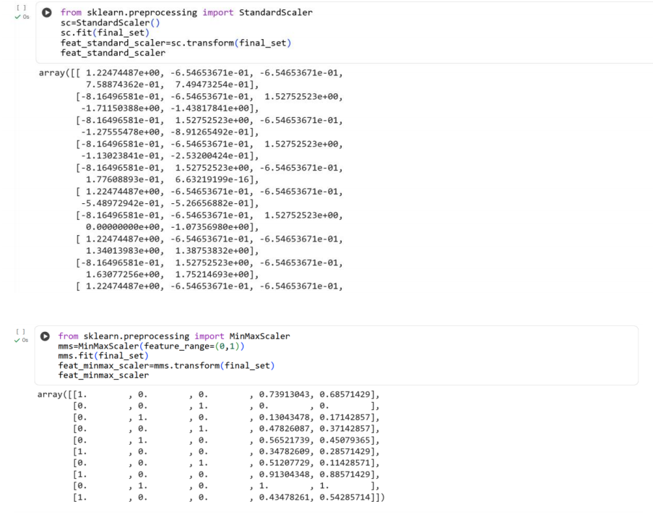
Result:
Thus the python program to do feature scaling in given dataset is executed and verified
successfully

